Sequence diagram SIRALAMA DİYAGRAMI

<https://app.creately.com/d/4BCS7ggYOfB/edit>

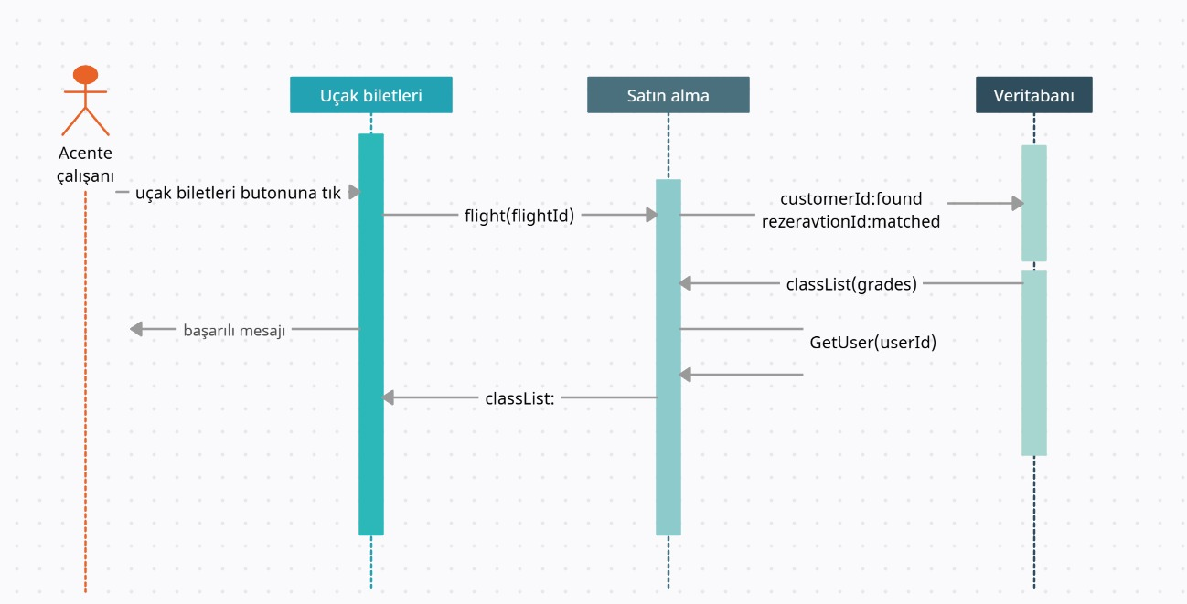

**b. Etkinlik Diyagramı**

**(Activity Diagram)**

<https://app.creately.com/d/3bujGCWluJf/edit>

